10.1 Dilations
NAME: ___________________________________________________ HOUR: ______________
State whether a dilation with the given scale factor is a reduction or an enlargement.
1. k = 3 2. k = $\frac{1}{3}$ 3. k = $\frac{5}{4}$ 4. k = 0.93
Determine the dilation from Figure A to Figure B is a reduction or an enlargement. Then find its scale factor.
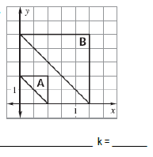
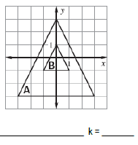
5. 6.

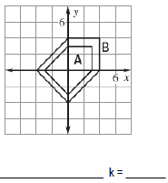
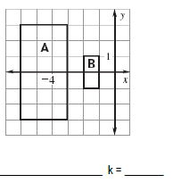
7. 8.

Point T is a vertex of a triangle. Point M is the image of T after the dilation. Find the scale factor k of the dilation.
9. T (2 , 7) and M (6 , 21) 10. T (6 , 9) and M (2 , 3) 11. T (-4 , -8) and M (-28 , -56)

A line segment has the given endpoints. Use the scale factor to write the ordered pair after the dilation.
12. P(1,1), T(3,1) and k = 2 13. R(4,4), D(8,12), and k = $\frac{3}{4}$ 14. K(0,0), B(-3,2), and k = 5
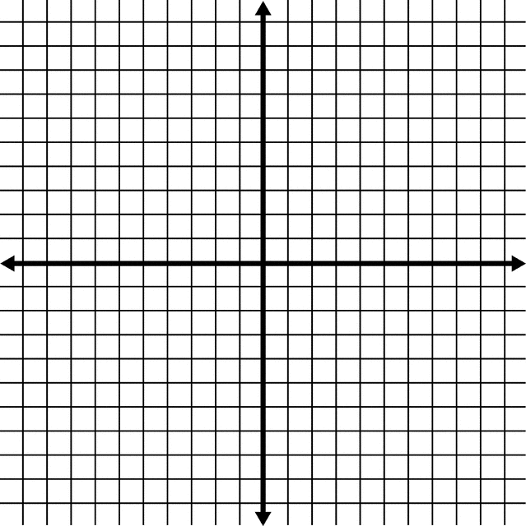
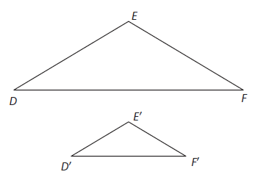
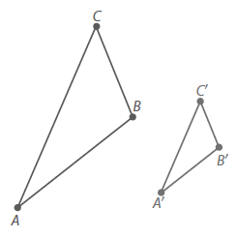
Determine the center of dilation for the following:
15. 16.

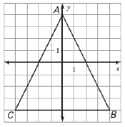
Draw the dilation of the figure using the given scale factor:
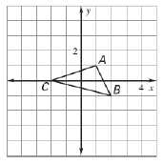
17. k = 2 18. k = $\frac{1}{4}$

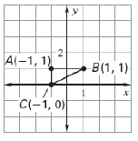
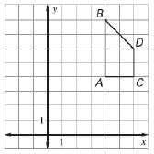
19. k = $\frac{1}{2}$ 20. k = 3

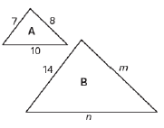
Determine whether the dilation from Figure A to Figure B is a reduction or an enlargement. Then, find the scale factor and the other values for the side lengths.
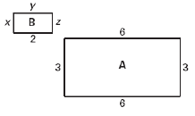
21. 22.

