**10.4 Applications of Similarity**

Name______________________________________________________________________________Hour____________

*Use the diagram to complete Exercises 1-4.*

|  |
| --- |
| 1. 2. 3. |

4. If ___________cm.

*5-6 Determine whether each pair of triangles is similar. Justify your answer.*

5. 6. 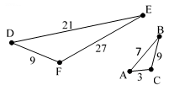

7. A 9ft tall stop sign casts a 12ft shadow. A building near this stop sign casts a 63ft shadow.  
a) How tall is the building? b) If the distance from the top of the building to the end of the shadow is 87ft, what is the distance from the top of the stop sign to the end of its shadow?

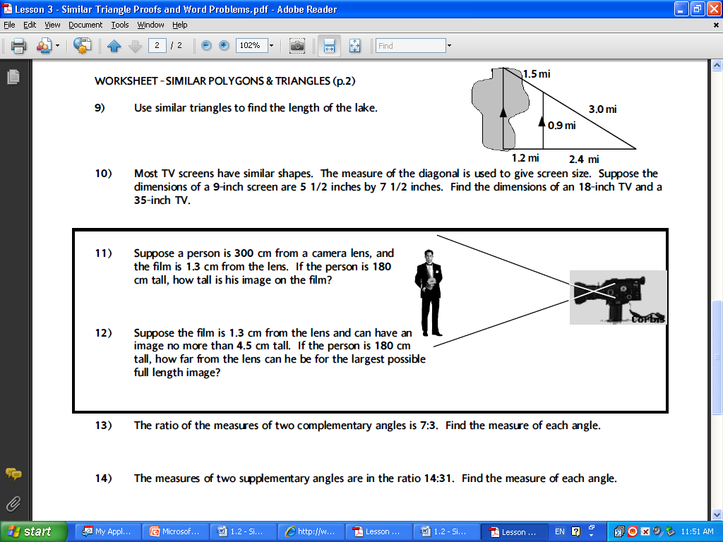

8. Find the length of the lake.

9. A Tower casts a shadow of 64 feet. A 6-foot pole near the tower casts a shadow 8 feet long. How tall is the tower?

10. A ladder that is 30ft tall leans 25ft up against the side of a building. Up against the same building, how far up would a 20ft ladder go?

11. Sam built a ramp to a loading dock. The ramp has a vertical support 2 meters from the base of the loading dock and 3 meters from the base of the ramp. If the vertical support is 1.2 meters in height, what is the height of the loading dock?

12. Emily is moving and needs to pack two mirrors. The largest mirror fits in a box that is 18 inches by 20 inches long. Her smaller mirror is similar in proportion to the larger mirror. Emily determines that the width of the smaller box needs to be a minimum of 9 inches. What should the minimum length of the box be to hold the smaller mirror?

13. A flagpole casts a shadow 48 feet long at the same time that a 6 foot tall person casts a shadow 24 feet long. Find the **height** of the flag pole and **explain** why you know the triangles are similar.

h



6’

24’

48’

