**11.2 Using Theorems of Lines and Transversals** **Name ____________________________Hr _____**

For 1-4. Circle if the statement is (A) always, (S) sometimes or (N) never true.

1. If two lines are both perpendicular to the transversal, are they parallel to each other? A S N

2. If two lines are cut by a transversal, the alternate interior angles are supplementary. A S N

3. If two lines cut by a transversal form alternate exterior angles that are congruent, the two lines are parallel. A S N

4. If two angles are vertical, they are supplementary. A S N

5. Match the given angles with their relationship:



1)  and  are ___. A. Alternate Interior

2)  and  are ___. B. Corresponding

3)  and  are ___. C. Consecutive Interior

4) and are ___. 4. Vertical Angles

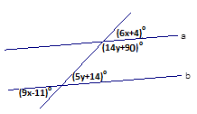6. Use the following picture to answer the following questions.

a) What value of x will guarantee that lines a and b are parallel?

b) What value of y will guarantee that lines a and b are parallel?

c) Using the values for x and y what are the measures of (9x-11)° and (5y+14)°?

7. For the following pictures, find all eight angles using the given information.

a) Given find the measure of all 8 angles. b) Given find the measure of all 8 angles.



8. Put a check mark by all of the statements that guarantee m and n are parallel?

a)  and 

b)  and 

c)  and 

d)  and 

e)  and 

9. Identify which, if any, of the lines in the picture are parallel with the following information.

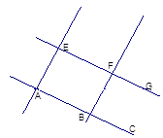

a) 

b) 

c) 

d) °

10. Given that lines a ǀǀ b and m ǀǀ n fill in the blank with the relationship (congruent or supplementary) that exists.



a)  _______________ b)  _______________

c)  _______________ d)  _______________ e) Given . What is? _____ f) Given . What is? ___

11. Given that WXYZ is a parallelogram and , find the measures of the other three angles.



12. Find the value for x and y that makes the following shape a parallelogram.



13. Use the following sketch of parallelogram ABCD to find the measures of :

a)  b)  c)  d) 

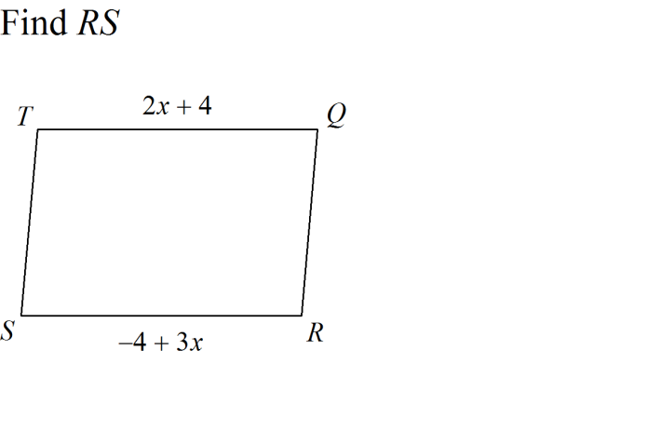14. Solve for x. 15.

