12.1 Circumference, Area, Radians of a Circle
Name: ________________________________________________ Hour: ____________
1. Draw a circle and identify where the circumference is located.

2. Draw a circle and identify what the area represents.

3-7: Find the circumference of each circle with the given radius or diameter. Round to the nearest tenth, use 3.14 for $π.$ Please be sure to include the units of measure.
3. $r=9 cm$ 4. $r= 24 in$ 5. $d=59 ft$

6. A pop can that has a radius of 1.25 in 7. The alien’s crop circle has a diameter of 667 ft.

8-12 Find the Area of each circle with the given radius or diameter. Round to the nearest tenth, Use 3.14 for $π$. Please be sure to include the units of measure.
8. $r=3.14 mm$ 9. $d=25 yds$ 10. $6.6 ft$

11. The top of a Frisbee has a diameter of 11.5 in 12. Parker’s 1897 silver dollar has a radius of 2.75 cm

13-15: Find the area of the circle with the given circumference. Use 3.14 for $π.$ Round to the nearest tenth.
13. $C=31.4 ft$ 14. $C=105 yd$ 15. $C=92.75 cm$
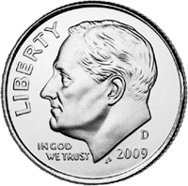
16. A dime has a circumference of 53.41 mm. What is the area of the dime?

17. Find the diameter of a CD with an area 113.1 cm².

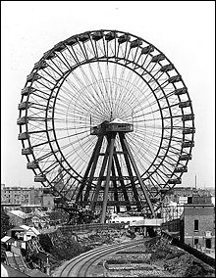
18. A Ferris wheel has a diameter of 56 ft.
a) How far will an individual travel if the wheel rotates once?
b) How far will they travel during a 4-minute ride if it rotates once every 20 seconds?

