12.2 Arc Length
NAME: _______________________________________________ HOUR: ___________
1. The distance from point A to point B, on the outside of a circle is called the ____________________

2-11: Convert the following from degrees to radians, or radians to degrees.
2. $40°$ 3. $\frac{π}{2}$ Radians 4. $180°$ 5. $270°$ 6. $2π$ Radians

7. $\frac{π}{4}$ Radians 8. $\frac{π}{6}$ Radians 9. $320°$ 10. $\frac{3π}{2}$ Radians 11. $\frac{5π}{6}$ Radians

12. How do you find the Arc Length of a circle using degrees and radians?
-Degrees:
-Radians:

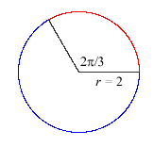
13-15: Find the arc length from point A to point B to the nearest tenth.
A
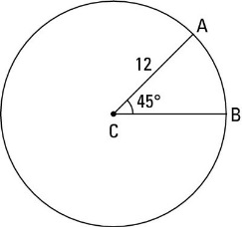
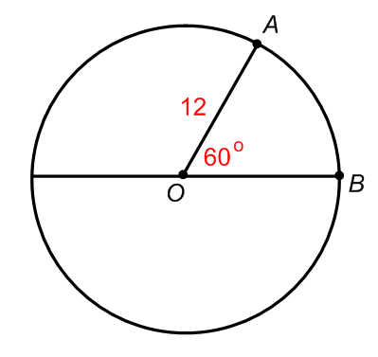
13. 14. 15.
Radians
B

16. The minute hand of a clock is 6 inches long. If the hand moves from 1:05 to 1:25, what is the distance the tip of the hand moves, to the nearest tenth?

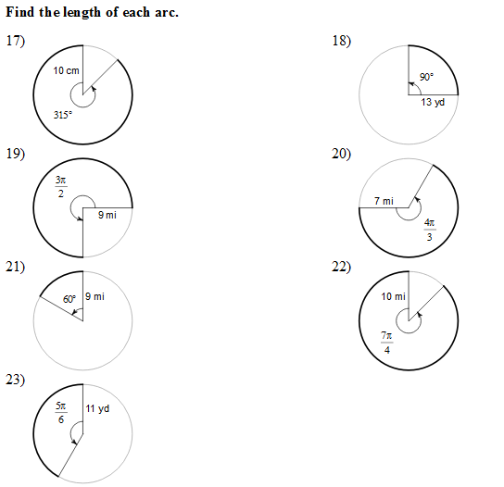
24-26: Consider a standard 12-hour clock like the one below with a radius of 5 inches.
Use this to answer questions 16-20. Use the shortest path between the two numbers.
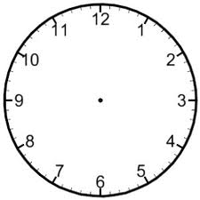
24. What is the length of the arc between the 3 and the 7?

25. What is the length of the arc between the 3 and the 2?

26. It is 1:25. What is the length of the arc between the minute and hour hands?

