12.2B Sector Area
NAME: _______________________________________________ HOUR: ___________

1. The region within a circle bounded by two radii and an intercepted arc is called ___________
2. How do you find the sector area of a circle using degrees and radians?
-Degrees:
-Radians:
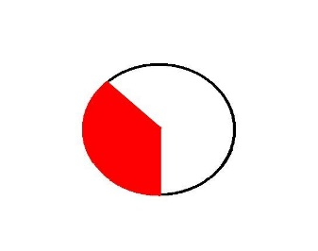
3-5: Find the shaded Sector area in the following circles.
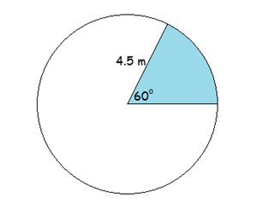
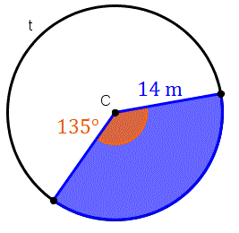
3. 4. 5.
r = 4 yds
$$\frac{3π}{4} radians$$

6. The beam from a lighthouse is visible for a distance of 15 miles. What is the area covered when the beam sweeps in an arc of $270°$? To the nearest tenth.

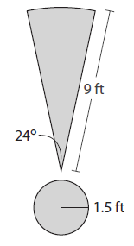
7. The exclamation point on a billboard consists of a circle sector and a circle, like the one to the right. What is the total area of the exclamation point?

8. You eat three pieces of a pizza that has a radius of 10 inches. The pizza is
divided into eight even slices. What is the area of the pizza you ate?
9. A large pizza has a radius of 12in. What is the area of half of the large pizza?
10. A slice is removed from a pizza with a radius of 10 inches. The length of the crust of the missing slice is 3 in. What is the area of the missing slice?

