Write the equation of the circle.
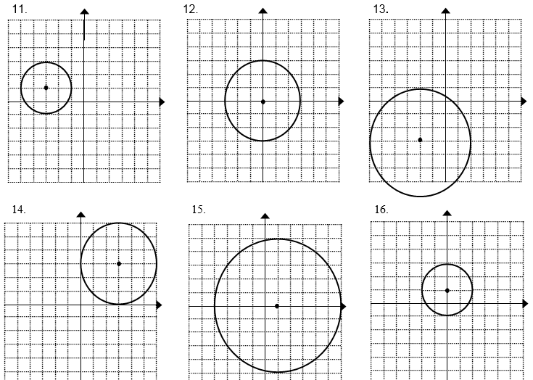

23- Write an equation for the circle representing the circle and solve the problem.
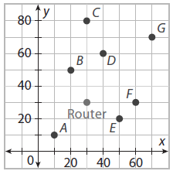
23. A router for a wireless network has a range of 35 feet. The router is located at the point (30,30) on the graph. The other points are computers in the office building. Which computers will not be able to connect to the internet?

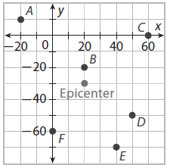
24. An earthquake’s epicenter is located at the point (20,-30) on the graph. The earthquake is felt 40 miles away. Which cities will feel the earthquake?

