12.4 Central and Inscribed Angles

NAME: __________________________________________________ DATE: ___________

1. Find the parts of \bigodot A that best fits each description.

|  |  |  |
| --- | --- | --- |
| http://www.ck12.org/flx/show/image/user%3Ack12editor/201207231343096760835408_a26d6d4ea5298520d4d01c6118eb5664-201207231343097037389161.png | a) A radius  b) A chord  c) A tangent line | d) A point of tangency  e) A diameter  f) A secant |

2. Are any of the following circles congruent? EXPLAIN how you know.   
 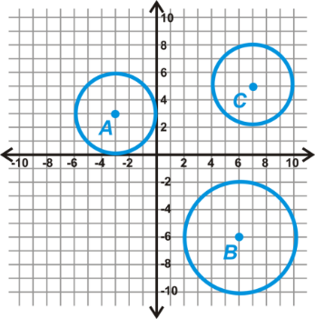

3. Is it possible to have a line that intersects a circle three times? If so, draw one. If not, explain.

4. Do you think all circles are similar? Explain.

5. What is the longest chord in any circle?

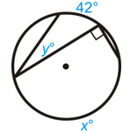6-8: Using your knowledge of the Central angle and inscribed angle theorem, find the value for x or y.

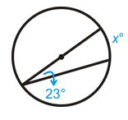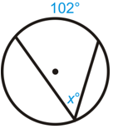6. 7. 8.

In Circle W, $m\hat{XZ}=60°$, $m∠VYZ=40°$, and YZ is a diameter. Find the following:

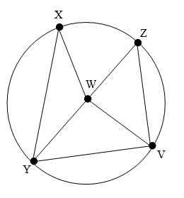

9.  10. 

11.  12. 

13. 14.

15. 16. 

17. 18. 

19-21: Using your knowledge of the Central angle and inscribed angle theorem, find the value for x or y.

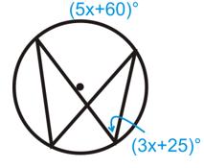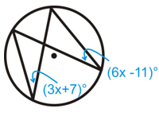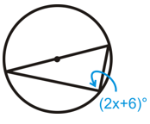

19. 20. 21.

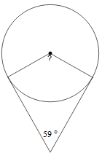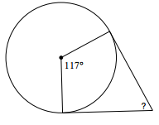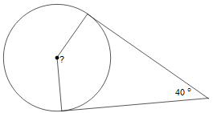Solve for all the unknown angle and the angles formed by the tangent line and radius.

22. 23. 24.

25. What is the Central angle theorem?

26. What is the Inscribed Angle Theorem?

27. What is the Circumscribed Angle Theorem?