13.2 Trig ratios
NAME: ____________________________________________________ HOUR: ______________
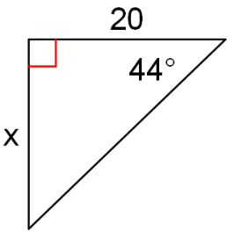
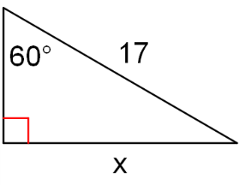
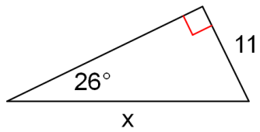
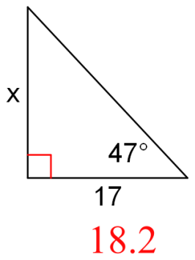
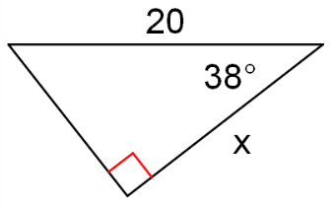
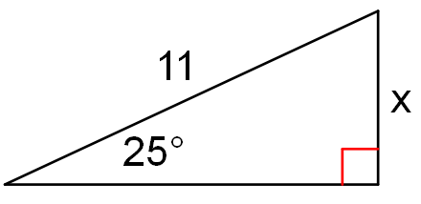
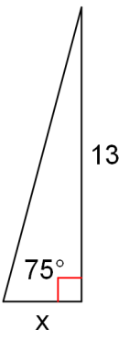
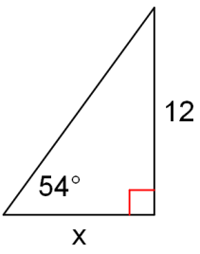
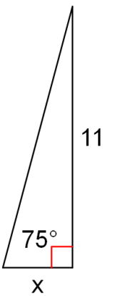
Find the value of each variable using SOH-CAH-TOA
2.
3.
1.

5.
6.
4.

9.
8.
7.

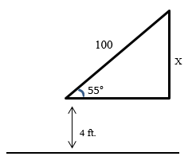
10. Holly is flying her kite. The hand holding the string is 4 feet
above ground level and the string makes an angle of 55° above horizontal.
When she has 100 ft. of string out, how high is the kite above the ground?

Find each angle measure to the nearest degree.
11. $\sin{y}=0.8829$ 12. $\tan{w}=57.2900$ 13. $\cos{v}=0.5878$

14. $\cos{b}=0.1736$ 15. $\tan{w}=4.0108$ 16. $\sin{z}=0.6691$

Find the measure of the indicated angle to the tenth of a degree.
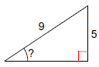
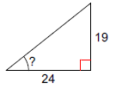
17. 18.

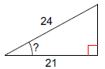
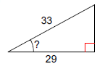
19. 20.

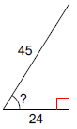
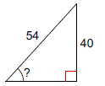
21. 22.

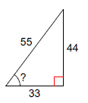
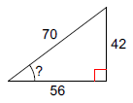
23. 24.

