13.3 Complementary Angles
NAME: _________________________________________________ HOUR: _____________
1. If $\cos{x}=\frac{4}{5}$, what is the $\sin{x}=$ 2. If $\tan{x}=\frac{12}{5}$, what is the $\sin{x}=$

3. If $\cos{x}=\frac{4}{8}$, what is the $\tan{x}=$ 4. If $\sin{x}=\frac{12}{13}$, what is the $\cos{x}=$

5. If $\tan{x}=\frac{24}{21}$, what is the $\cos{x}=$ 6. If $\sin{x}=\frac{2}{3}$, what is the $\tan{x}=$

Rewrite each equation using complements and the other trig function.
7. $\cos{12°=______}$ 8. $\sin{43°}=______$ 9. $\sin{89°=______}$ 10. $\cos{31°=_______}$

11. sin 5º = _____ 12. cos 81º = _____ 13. sin wº = _____ 14. cos tº = _____

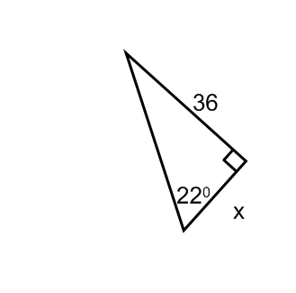
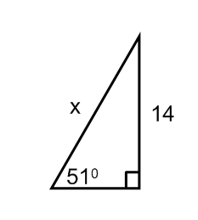
Solve for x in each of the following triangles.
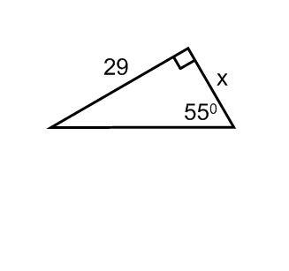
15. 16. 17.

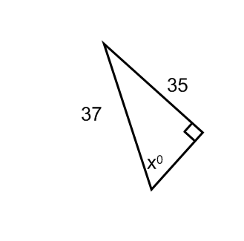
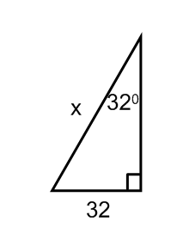
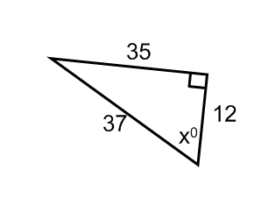
18. 19. 20.

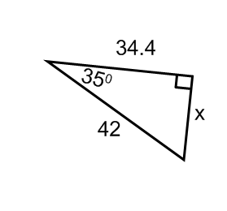
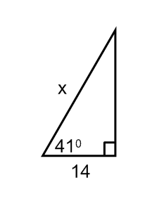
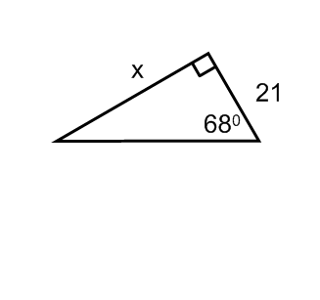
21. 22. 23.

