9.2 Two-way Tables and Probability
NAME: __________________________________________________ HOUR: ____________
1. Define Mutually Exclusive Events.

2. Define Overlapping Events.

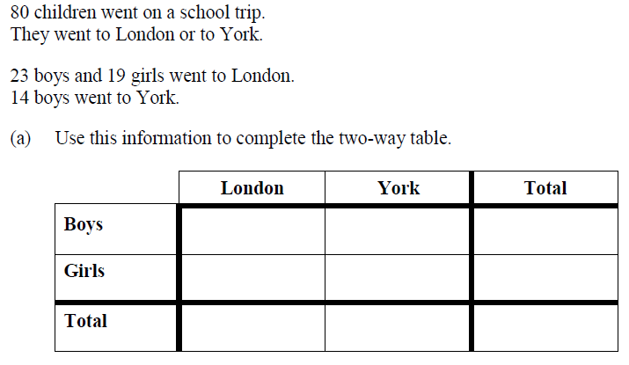
3.

4. Complete the following table about the number of students in a school, then use it to answer the following questions, when making one draw from the total group.
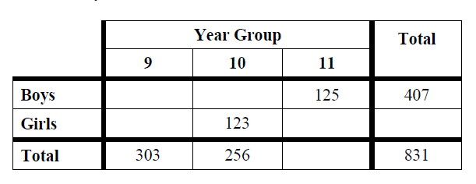

5.$P\left(9 and Boy\right)$ 6. $P\left(10 and Girl\right)$

7. $P(11∩ 10)$ 8. $P(11 ∩ Girl)$

9. Complete the table below
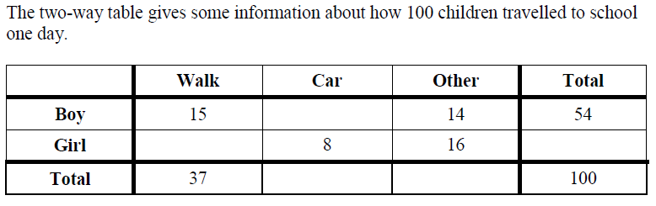

10-13 If you randomly select one child from the group, find the following probabilities.
10. $P\left(Boy∩Car\right)$ 11. $P\left(Girl ∪Walk\right)$

12. $P\left(Boy ∪Other\right)$ 13. $P\left(Girl ∩Car\right)$

14. Create a two-way table using the following information.
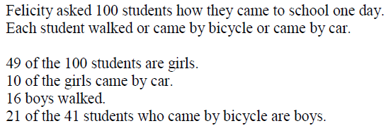

If you randomly select a student from the group, find the probabilities of the following
15. $P\left(Walk\right)$ 16. $P\left(Car or Boy\right)$

17. $P(Bicycle ∪Girl)$ 18. . $P\left(Walk ∩Boy\right)$

