9.3 Conditional Probability
NAME: ____________________________________________________ HOUR: __________

1-6 You randomly select a card from a standard deck of cards. Let event A be that the card is an Ace. Let Event B be that the card is Black. Let Event C be that the card is a Club. Let Event D be that the card is a 10. Find the following Probabilities.

1. $P\left(A | B\right)=$ 2. $P($B|D) = 3. $P\left(C | A\right)=$

4. $P\left(D | A\right)=$ 5. $P\left(B | C\right)=$ 6. $P\left(D | C\right)=$

7. A six sided die is rolled what is $P\left(less than 5 | even\right)=$

8. A number is selected, at random, from the set . Find:
a) $P(odd)$

b) $P(prime|odd)$

9. A box contains three blue marbles, five red marbles, and four white marbles. If one marble is drawn at random, find:
a) $P(blue|not White)$

b) $P(not Red|not White)$

The following table shows the amount of sleep a student got before a test and the performance on the test. Use the table to answer the following questions.
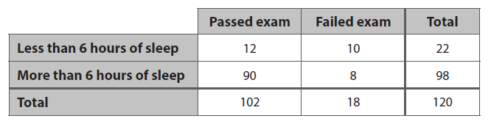
12. If you select one student at random, what is the probability that you select a student that failed the exam, if they got more than 6 hours of sleep?
13. If you select one student at random, what is the probability that you select a student that got less than 6 hours of sleep, if they failed the exam?

14. If you select one student at random, what is the $P\left(more than 6 hours of sleep | failed exam\right)$

15. If you select one student at random, what is the $P\left(passed exam | more than 6 hours of sleep\right)$

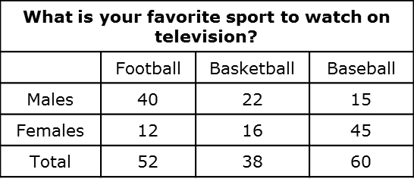
Use the table to answer the
Following questions on sports.
You make one selection from
The sample space.

16. $P\left(Male | football\right)$

17. $P\left(basketball | Female\right)$

18. $P\left(Female | Baseball\right)$

19. $P(Female|Basketball)$

20. $P(Football|Male)$

