**MIDTERM TEST Name:_________________________ Hour:_____**

UNIT 8

Factor and solve the following:

1. 2.

3. 4.

Solve the following systems of equations for both x and y.

5. 6.

7. Write the following phrase as an expression: “Sum of three times a number n and six”.

8. Write the following expression as a phrase: $3-\frac{76}{x}$

UNIT 9

Sample Space: {1, 2, 3, 4, 5, 6, 7, 8, 9, 10} Set A: {1,2,3,4,5} Set B: {1,3,5,7,9} Set C: {1,2,3}

Using the above information answer the following questions.

9. What is 10. What is _____________________________

11. a) Is A ⊂C? Circle one. YES NO 12. What is $B^{c}?$

______________________________

b) Is C ⊂A? Circle one. YES NO

Find the following probabilities using the given chart.

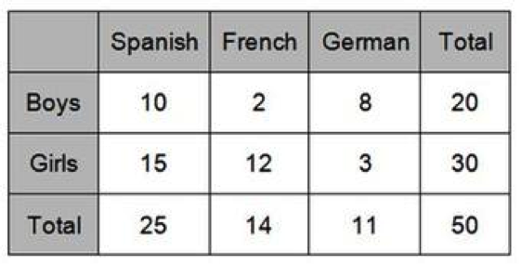

13. 14. ) 15.

16. 17.

UNIT 10

Identify whether each of the following dilations is an enlargement or reduction. If not given, find the scale factor.

18. k=.89 19. ABC 🡪 A’B’C’

20. K=6/5

21. A(0,3)🡪A’(0,1.5)

Identify if the following pairs of triangles are similar. If yes, state which theorem was used and complete the similarity statement.

22.

Similar? YES NO

Similarity Theorem/Test:

$∆EBN\sim _________________$

________________

Graph the following translations:

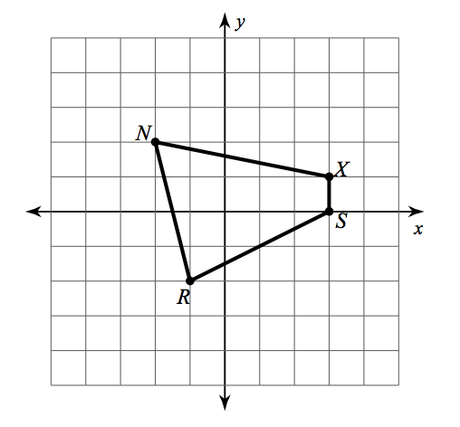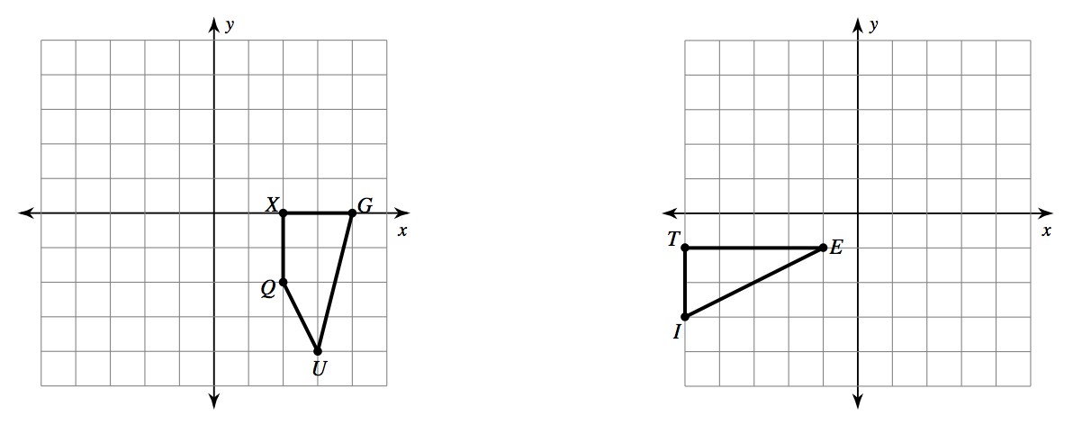23. Dilation of 2 24. Rotate 180 degrees

UNIT 11

25. Find the measures of the seven missing angles.

26. State a pair of angles for each of the following. (Note that angle 8 is the one that is labeled 135 degrees)

Alternate Interior:

Alternate Exterior:

Corresponding:

Consecutive Interor:

Vertical:

27. Write the following for given conditional statement “If it is a frog, then it is an amphibian”

Converse:__________________________________________________________________________________

Inverse:___________________________________________________________________________________

Contrapositve:______________________________________________________________________________

28. Given: and

Prove: $∠4=45°$