Unit 9: Probability
Guided Notes

_________________________________________________
Name

______________
Period

**If found, please return to Mrs. Brandley’s room, M-8**

Self-Assessment
The following are the concepts you should know by the end of Unit 1. Periodically throughout the unit I will ask you to self-assess on how you are doing on these skills. It is essential for you to be able to identify what you do and do not understand in order to learn effectively. You will use the following scale:
5: Yes! I understand
4: I’m almost there.
3: I am back and forth.
2: I am just starting to understand.
1: I don’t understand at all.

Concept 1: Set Notation and Basic Probability
_____ I can find the probability of an event happening in both fraction, decimal, and percentage form.
_____ I can write a sample space in set notation.
_____ I know what a subset is and can tell if one set is a subset to another.
_____ I know what a union, intersection, and complement are can find them given various sets.
Concept 2: Frequency Tables and Conditional Probability
_____ I can construct a two-way frequency table given data points.
_____ I know what joint and marginal probabilities are and can find them from a frequency table.
_____ I can find a conditional probability using a frequency table.
_____ I can find a conditional probability using the formula.
Concept 3: Reasoning with Probability
_____ I can decide if various situations are fair and use probability to defend my answer.

Concept 1: Set Notation
Sample Space: Set of all possible outcomes
Sample Size: Total number of possible outcomes
Ex: 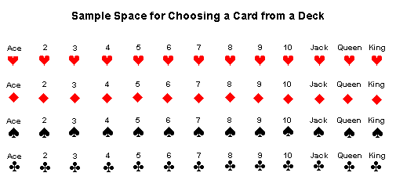
Set: Collection of distinct elements
Subset: A set of which all the elements are contained in another set. Example: Set A: {1,2,3,4,5} and Set B: {1,3,5}. Thus B$⊂$A, which is said B is a subset of A.
Set Notation: {element, element, element, element}
Intersection: $∩$ OR AND
Union: $∪$ AND OR

Compliment: $X^{c}$NOT

Basic Probability:
1. P(3 of hearts) 2. P(jack) 3. P(diamond)

4. P(even number) 5. P(face card) 6. P(2 or 7)

Use the following sets for the following questions. The SAMPLE SPACE is the numbers 1 thru 20
Write out the sample space here:
Set A is the set of odd numbers.
Write out Set A/E here:
Set B is the set of even numbers.
Write out Set B/F here:
Set C is the multiples of 5 less than 21.
Write out Set C/G here:
Set D is all prime numbers less than 21.
Write out Set D here:
1. Is $B⊂A?$ 2. Is $D⊂B?$ 3. Is $D⊂A?$

4. What is $D∪E?$ 5. What is $D∩E?$

6. What is $E∩G?$ 7. What is $F∪G?$

8. What is $D^{c}?$ 9. What is $E^{c}?$

10. What is $P(D)?$ 11. What is $P(G)?$

12. What is $P(G∪F)?$ 13. What is $P(E∩G)?$

Concept 2: Frequency Tables and Conditional Probability

Formula for Conditional Probability
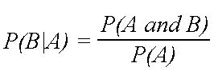
- What is the probability someone plans a vacation to NY within a year if they watch the online ad?

- What is the probability that someone plans a vacation to NY within a year if they do not watch the online ad?

- Do you think the ad works? Why or why not?

4. A box contains three blue marbles, five red marbles, and four white marbles. If one marble is drawn at random, find:
a) $P(blue|not White)$
b) $P(not Red|not White)$

5. A number is selected randomly from a container containing all the integers from to . Find:
a) $P(even|greater than 40)$
b) $P(greater than 40|even)$
c) $P(prime|between 20 and 40)$

Concept 3: Reasoning with Probability
Answer the following questions and use probability to defend your answer.
1. Dylan and Cade split the cost of a package of five passes to a climbing gym. Describe a way that you could fairly decide who gets to use the fifth pass.

2. In addition to prizes for first, second, and third place, the organizers of a race have a prize that they want each participant to have an equal chance of winning. Describe a fair method of choosing a winner for this prize.

3. Two teams are playing a game against one another in class to earn 10 extra points on an assignment. The teacher said that the points will be split fairly between the two teams, depending on the results of the game. If Team A earned 1300 points and Team B earned 2200 points describe one way the teacher could split up the 10 extra points.

4. Joslin and McCall are at a yard sale, and they find a box of 20 collectible toys they both want. They can’t agree about who saw it first, so they flip a coin until Alexa gets 10 heads or Sofia gets 10 tails. When Alexa has 3 heads and Sofia has 6 tails, they decide to divide the toys proportionally based on the probability each has of winning under the original rules. How should they divide the toys?

5. Bernard and Braxton are fighting over who gets to pick where to go to lunch. They decide to roll a die to decide who gets to choose. Bernard says he gets to choose if the they roll less than a 4 and Braxton gets to roll if it’s greater than 4. Is this a fair way to choose? Why or why not?

