Unit 10 Similarity and Transformations

Guided Notes

_________________________________________________

Name

______________

Period

**If found, please return to Mrs. Brandley’s room, M-8.**

**Self-Assessment**

The following are the concepts you should know by the end of Unit 1. Periodically throughout the unit I will ask you to self-assess on how you are doing on these skills. It is essential for you to be able to identify what you do and do not understand in order to learn effectively. You will use the following scale:

5: Yes! I understand

4: I’m almost there.

3: I am back and forth.

2: I am just starting to understand.

1: I don’t understand at all.

**Concept 1: Dilations**

_____ I can state whether a dilation is a reduction or enlargement based on its scale factor or graph.

_____ I can find a scale factor of a dilation from the graph.

_____ I can find the scale factor of a dilation given a point from before and after the dilation.

_____ I know that the dilation of a line that goes through the center of dilation stays on the same line.

_____ I know that the dilation of a line that does not go through the center of dilation is parallel to the original line.

**Concept 2: Transformations**

_____ I can translate figures left, right, up, and down.

_____ I can reflect figures over the x-axis and y-axis.

_____ I can rotate a figure 90 degrees, 180 degrees, and 270 degrees.

**Concept 3: Triangle Similarity**

_____ I know the AA, SSS, and the ASA theorems and can use them to prove triangles are similar.

**Concept 4: Applications of Similarity**

_____ I can use what I learned about similar triangles to solve real-world problems.

**Concept 1: Dilations**

Dilation:

Enlargement:

Reduction:

Scale Factor:

Center of Dilation:

State whether the following dilations are a reduction or an enlargement based on their scale factor(k):

k=3 k=1/3 k=3/2 k=.67

Determine whether the dilation is a reduction or an enlargement. Then find it’s scale factor.

From Orange to Blue From Green to Purple

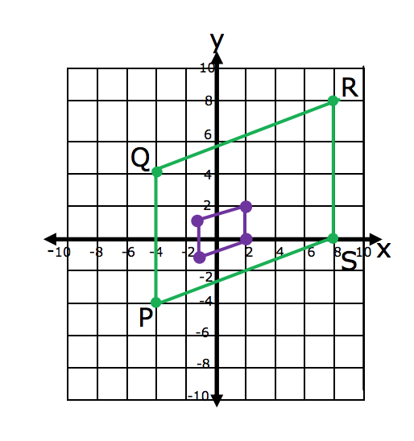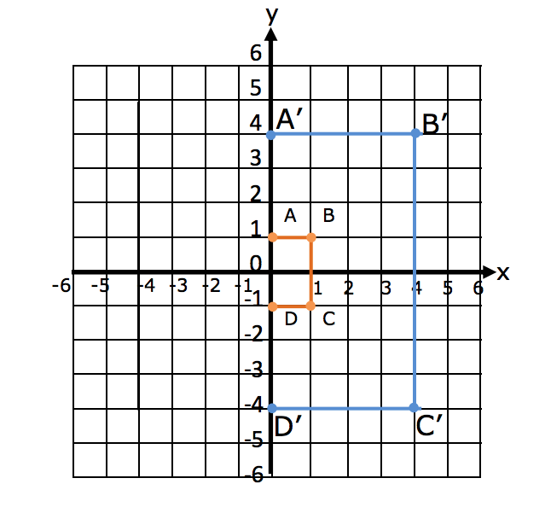

Scale Factor, K= Scale Factor, K=

Draw the shape after a dilation with the given scale factor:

K=1/4 K=4 K=2

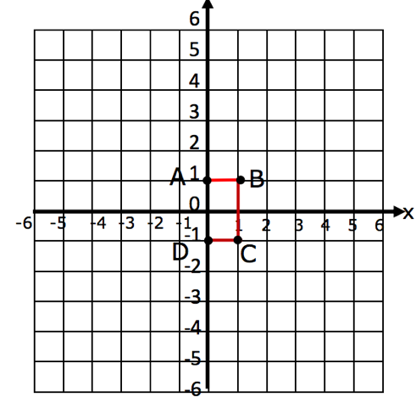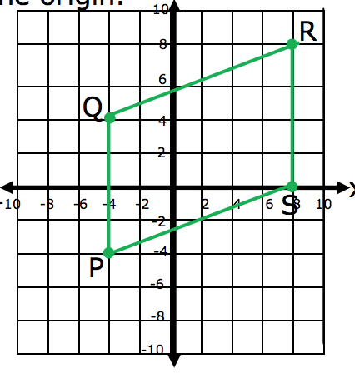

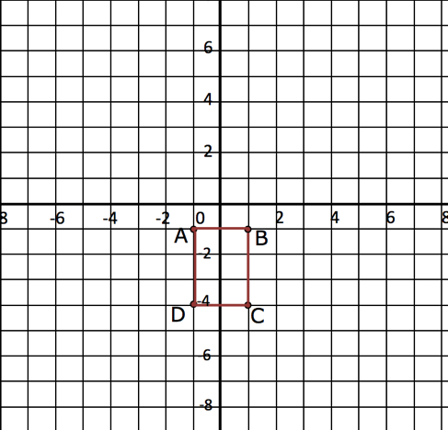

Point T is a vertex of a triangle. Point M is the image or T after the dilation. Find the scale factor k of the dilation.

1. T (1 , 5) and M (2 , 10) 2. T (4 , 8) and M (2 , 4) 3. T (-3 , -6) and M (-15 , -18)

K= K= K=

A line segment has the given endpoints. Use the scale factor to write the ordered pair after the dilation. (Center of Dilation is at (0,0))

4. P(1,1), T(3,3) and k = 2 5. R(1,3), D(2,5), and k = 3/4 6. K(0,0), B(3,-2), and k = 5

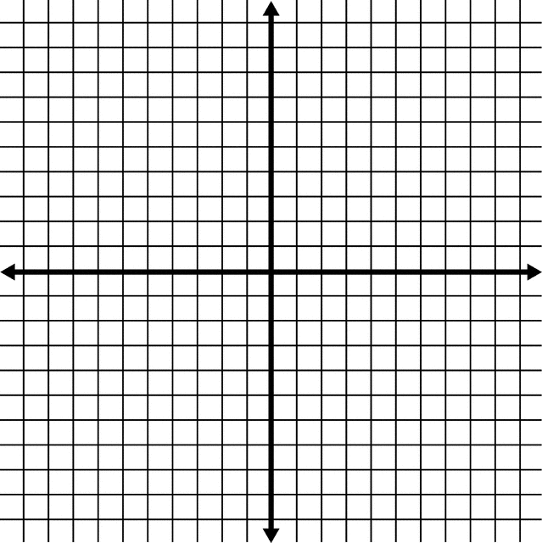

NOTE: When the original line passes through the origin, the image stays the same. If the original line does not pass through the origin, it is parallel to the original line.

You can determine the center of dilation of by drawing straight lines between the corresponding points of the shapes and seeing where they intersect. This intersection point is the center of dilation.

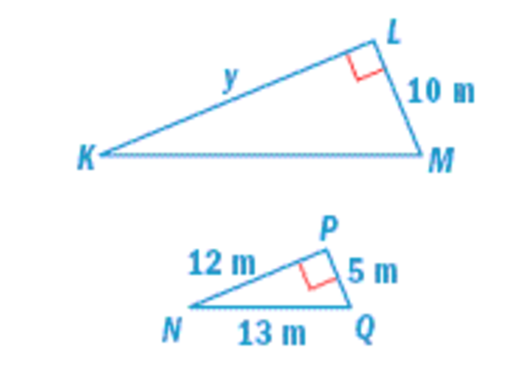Find the missing side length(s) of the following dilated shapes:

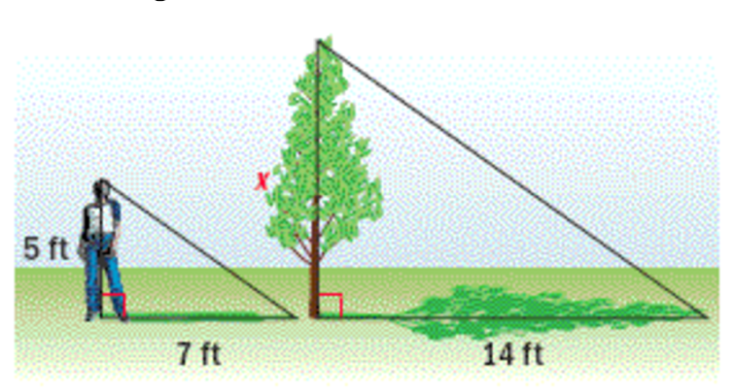

The screen on your old television is 20 inches wide and 15 inches high. The screen on your new widescreen television is 16 inches wide and 9 inches high. Is the screen on your new TV a dilation of the screen on your old TV? Explain.

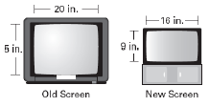

**Concept 2: Transformations of Figures**

Use the following website to explore and determine a rule for transformation of rigid objects.

http://www.shodor.org/interactivate/activities/Transmographer/

Use a TRIANGLE FOR THE FOLLOWING QUESTIONS.

1. Write the ordered pairs for the preimage below and name them.

2. Translate the object on the x axis 3 units. Write the new corresponding order pairs, how did it move the preimage? Then hit the reset button.

3. Translate the object on the x axis 1 units. Write the new corresponding order pairs, how did it move the preimage? Then hit the reset button.

4. Translate the object on the x axis -2 units. Write the new corresponding order pairs, how did it move the preimage? Then hit the reset button.

5. Translate the object on the x axis -3 units. Write the new corresponding order pairs, how did it move the preimage? Then hit the reset button.

6. NOW THE IMPORTANT PART. Write a rule for how the ordered pairs change that works for all translations right or left. Check your rule, by using the website.

7. Translate the object on the y axis 3 units. Write the new corresponding order pairs, how did it move the preimage? Then hit the reset button.

8. Translate the object on the y axis 1 units. Write the new corresponding order pairs, how did it move the preimage? Then hit the reset button.

9. Translate the object on the y axis -2 units. Write the new corresponding order pairs, how did it move the preimage? Then hit the reset button.

10. Translate the object on the y axis -4 units. Write the new corresponding order pairs, how did it move the preimage? Then hit the reset button.

11. NOW THE IMPORTANT PART. Write a rule for how the ordered pairs change that works for all translations up or down. Check your rule, by using the website.

Use a different shape for each of the following questions

12. Write the ordered pairs for the preimage below and name them. Reflect the object about the x-axis = 0, write the new corresponding order pairs.

13. Write the ordered pairs for the preimage below and name them. Reflect the object about the x-axis = 0, write the new corresponding order pairs.

14. Write the ordered pairs for the preimage below and name them. Reflect the object about the x-axis = 0, write the new corresponding order pairs.

15. NOW THE IMPORTANT PART. Write a rule for how the ordered pairs change that works for all reflections about the x-axis. Check your rule, by using the website.

16. Write the ordered pairs for the preimage below and name them. Reflect the object about the y-axis = 0, write the new corresponding order pairs.

17. Write the ordered pairs for the preimage below and name them. Reflect the object about the y-axis = 0, write the new corresponding order pairs.

18. Write the ordered pairs for the preimage below and name them. Reflect the object about the y-axis = 0, write the new corresponding order pairs.

19. NOW THE IMPORTANT PART. Write a rule for the order pairs the works for all reflections about the y-axis. Check your rule, by using the website.

Use a different triangle for the following questions.

20. Write the ordered pairs for the preimage below and name them.

21. Rotate the triangle 90 degrees around the origin, write the new corresponding order pairs.

22. Write the ordered pairs for the preimage below and name them. Rotate the triangle 90 degrees around the origin, write the new corresponding order pairs.

23. NOW THE IMPORTANT PART. Write a rule for how the ordered pairs change that works for all rotations 90 degrees about the origin. Check your rule, by using the website.

24. Write the ordered pairs for the preimage below and name them. Rotate the triangle 180 degrees around the origin, write the new corresponding order pairs.

25. Write the ordered pairs for the preimage below and name them. Rotate the triangle 180 degrees around the origin, write the new corresponding order pairs.

26. Write the ordered pairs for the preimage below and name them. Rotate the triangle 180 degrees around the origin, write the new corresponding order pairs.

27. NOW THE IMPORTANT PART. Write a rule for the order pairs the works for all rotations 180 degrees about the origin. Check your rule, by using the website.

28. Write the ordered pairs for the preimage below and name them. Rotate the triangle 270 degrees around the origin, write the new corresponding order pairs.

29. Write the ordered pairs for the preimage below and name them. Rotate the triangle 270 degrees around the origin, write the new corresponding order pairs.

30. Write the ordered pairs for the preimage below and name them. Rotate the triangle 270 degrees around the origin, write the new corresponding order pairs.

31. NOW THE IMPORTANT PART. Write a rule for the order pairs the works for all rotations 270 degrees about the origin. Check your rule, by using the website.

**Rules for Translating**

Left and Right:

Up and Down:

Reflecting over X-axis:

Reflecting over Y-axis:

Rotating 90 degrees:

Rotating 180 degrees:

Rotating 270 degrees:

**Concept 3: Triangle Similarity**

Discovering Triangle Similarity

Draw a Triangle ABC with and . What is ? Measure the sides of Triangle ABC in cm.

Draw Triangle DEF with and . Make the length of DE longer than AB. What is? Measure the sides of Triangle DEF in cm.

|  |  |  |
| --- | --- | --- |
|  | SIDES | ANGLES |
| Triangle ABC | AB=  BC =  AC= |  |
| Triangle DEF | DE=  EF=  DF= |  |
| RATIO |  |  |

If two ____________ of one triangle are congruent to two ______________ of another triangle , then the triangles are_______________.

**This theorem is called: ___________________**

Draw Triangle ABC with AB , BC = 3cm, and AC= 4cm. Measure the angles of Triangle ABC to the nearest degree.

Draw Triangle DEF with DE= 6cm, EF = 9 cm, and DF= 12cm. Measure the angles of Triangle DEF to the nearest degree.

|  |  |  |
| --- | --- | --- |
|  | SIDES | ANGLES |
| Triangle ABC | AB= 2 cm  BC = 3 cm  AC= 4cm |  |
| Triangle DEF | DE= 6 cm  EF= 9 cm  DF= 12 cm |  |
| RATIO |  |  |

If the three ___________________ of one triangle are proportional to the three _______________ of another triangle, then the triangles are _________________.

**This theorem is called: ___________________**

Draw a Triangle ABC with AB= 3 cm, BC = 4cm, and . Measure the sides and angles of Triangle DEF.

Draw Triangle ABC with DE= 6cm, EF = 8 cm, and . Measure the sides and angles of Triangle DEF.

|  |  |  |
| --- | --- | --- |
|  | SIDES | ANGLES |
| Triangle ABC | AB= 3 cm  BC = 4 cm  AC= | 60 |
| Triangle DEF | DE= 6 cm  EF= 8 cm  DF= | 60 |
| RATIO |  |  |

If two _______________ of one triangle are proportional to two _____________ of another triangle and their _____________ _______________ are congruent, then the triangles are _______________.

**This theorem is called: ___________________**

**Similarity Theorems**

Angle-Angle (AA) Theorem: If two angles of one triangle are congruent to two angles of another triangle than the two triangles are similar.

Side-Side-Side (SSS) Theorem: If the three sides of one triangle are proportional to the three sides of another triangle than the two triangles are similar.

Side-Angle-Side (SAS) Theorem: If two sides of one triangle are proportional to two sides of another triangle and their included angles are congruent than the two triangles are similar.

Determine if the triangles are similar, if yes state which theorem you can use to prove it and write a similarity statement:

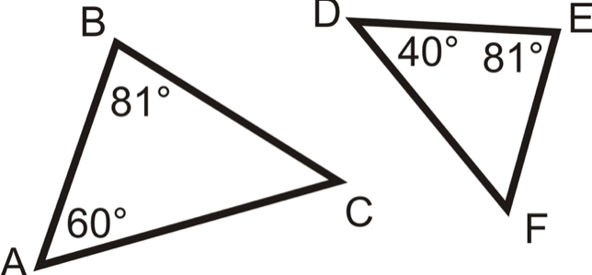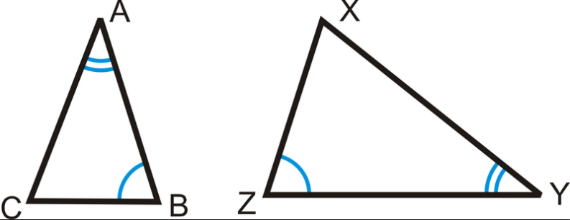

 

Decide if the following triangles similar, not similar, or there is not enough information. Explain why.

1. The three angles of triangle ABC are equal to the three angles of triangle DEF.
2. 2 of the sides of triangle ABC are proportional to two of the sides of triangle DEF
3. 2 of the angles of triangle ABC are equal to two of the angles of triangle DEF

If two triangles are similar, how do their angles relate? How do their sides relate?

What information could you have to know two triangles are similar? Give at least three possibilities.