Unit 11: Theorems with Lines

Guided Notes

_________________________________________________

Name

______________

Period

**If found, please return to Mrs. Brandley’s room, M-8.**

**Self-Assessment**

The following are the concepts you should know by the end of Unit 1. Periodically throughout the unit I will ask you to self-assess on how you are doing on these skills. It is essential for you to be able to identify what you do and do not understand in order to learn effectively. You will use the following scale:

5(A): Yes! I understand

4(B): I’m almost there.

3(C): I am back and forth.

2(D): I am just starting to understand.

1(E): I don’t understand at all.

**Concept 1: Lines and Transversals**

_____ I know what it means for two lines to be parallel.

_____ I know that congruent angles have the same angle measure.

_____ I know that supplementary angles add up to 180 degrees.

_____ I know what alternate interior angles are, can identify them, and that they are congruent

_____ I know what alternate exterior angles are, can identify them, and that they are congruent

_____ I know what consecutive interior angles are, can identify them, and that they are supplementary.

_____ I know what corresponding angles are, can identify them, and that they are congruent.

_____ I know what vertical angles are, can identify them, and that they are congruent.

_____ I can identify opposite sides, opposite angles, and consecutive angles in a parallelogram.

**Concept 2: Using Theorems of Lines and Transversals**

_____ I can use the theorems from concept 1 to find missing angle measures given a set of parallel line with a transversal.

_____ I can decide whether or not two lines are parallel based on given angle measures.

**Concept 3: Logic Statements**

_____ I can define conditional, converse, inverse, and contrapositive.

_____ Given a statement, I can write its’ conditional, converse, inverse, and contrapositive statements.

**Concept 4: Proofs with Parallel Lines**

_____ I can use the theorems from concept 1 to prove statements about parallel lines and angles.

**Concept 1: Lines and Transversals**

Parallel lines:

Congruent Angles:

Supplementary Angles:

Alternate Interior Alternate Exterior Consecutive Interior

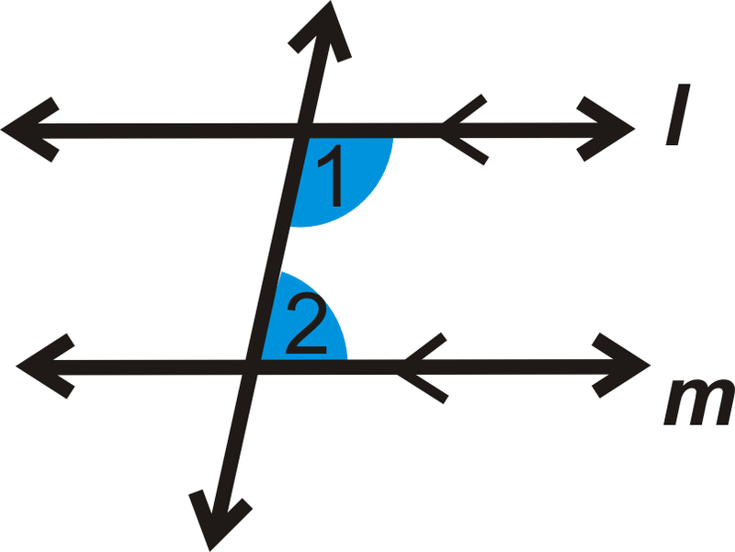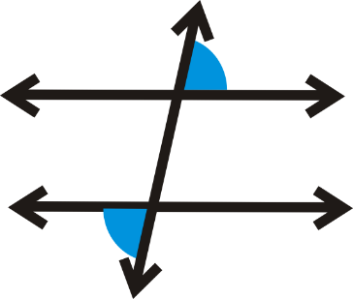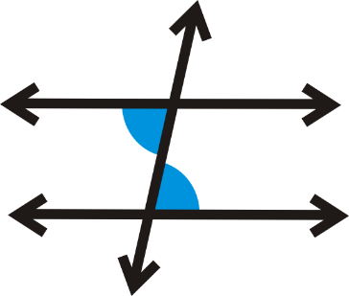

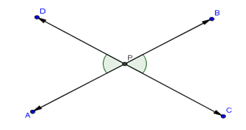Corresponding Vertical

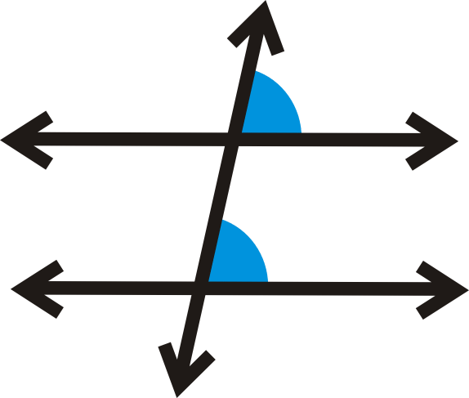

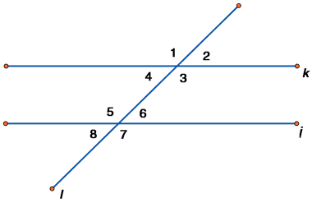Identify each pair of angles as alternate interior, alternate exterior, consecutive interior, corresponding or vertical. In each case, state if they are congruent or supplementary.

1.  3 and 7
2. 1 and 5
3. 2 and 6
4. 2 and 4
5. 1 and 3
6. 3 and 5
7. 4 and 6
8. 4 and 8

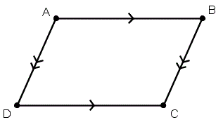Parallelogram: A quadrilateral (4-sided shape) where opposite sides are parallel and congruent and opposite angles are congruent.

Opposite sides are parallel and congruent.

Opposite angles are congruent.

Consecutive angles are supplementary.

**Concept 2: Using Theorems of Lines and Transversals**

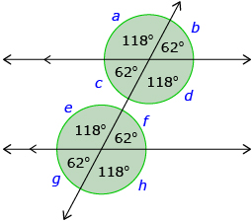**Note: If any of the following are true, the two lines must be parallel:**1) The alternate interior angles are congruent

2) The alternate exterior angles are congruent

3) The consecutive interior angles are supplementary.

4) The corresponding angles are congruent.

Based on the above, list 4 ways you could show the two lines in the figure on the right are parallel.

1.

2.

3.

4.

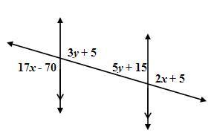**Given:** In the figure below, $∠1=80°$. Find the measure of each angle and give a justification.

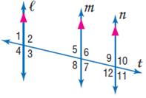

$m∠1=_______$ because

$m∠2=_______$ because

$m∠3=_______$ because

$m∠4=_______$ because

$m∠5=_______$ because

$m∠6=_______$ because

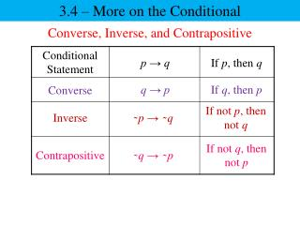**Concept 3: Logic Statements**

Example 1: I get good grades when I do my homework.

P:

Q:

Conditional Statement:

Converse:

Inverse:

Contrapositive:

Example 2: Snakes are reptiles.

P:

Q:

Conditional Statement:

Converse:

Inverse:

Contrapositive:

**Concept 4: Proofs with Parallel Lines**

