Unit 12: Circles, Arc Length, and Sector Area

Guided Notes

_________________________________________________

Name

______________

Period

**If found, please return to Mrs. Brandley’s room, M-8.**

**Self-Assessment**

The following are the concepts you should know by the end of Unit 1. Periodically throughout the unit I will ask you to self-assess on how you are doing on these skills. It is essential for you to be able to identify what you do and do not understand in order to learn effectively. You will use the following scale:

5(A): Yes! I understand

4(B): I’m almost there.

3(C): I am back and forth.

2(D): I am just starting to understand.

1(E): I don’t understand at all.

**Concept 1: Circumference and Area**

_____ I can find the circumference of a circle given the radius or diameter.

_____ I can find the area of a circle given the radius or diameter.

_____ I can find the radius of a circle given the circumference or area.

_____ I can find the circumference given the area or the area given the circumference.

**Concept 2A: Arc Length**

_____ I can convert radians to degrees and degrees to radians.

_____ I can find an arc length given the angle in degrees and the radius.

_____ I can find an arc length given the angle in radians and the radius.

**Concept 2B: Sector Area**

_____ I can find the sector area given an angle measure and the radius.

_____ I can solve story problems involving sector area.

**Concept 3: Equations of Circles**

_____ I can identify the radius and center of a circle from its’ equation in standard form.

_____ I can write the equation of a circle given its’ center and radius.

_____ I can complete the square to find the center and radius of a circle from an equation not in standard form.

**Concept 4: Circle Angles**

_____ I can identify parts of a circle.

_____ I know the inscribed angle theorem, central angle theorem, and circumscribed theorem.

_____ I can use the above theorems to solve for missing angles.

**Concept 5: Inscribed Quadrilaterals**

_____ I know that a quadrilateral has four sides and its’ four angles add to 360 degrees.

_____ I can use the properties of a quadrilateral and of circles to solve for missing angles.

**Concept 1: Circumference and Area**

Circumference: The length of the outside of a circle Circle Area: Size of the surface of the circle

$C=2πr$ $A=πr^{2}$

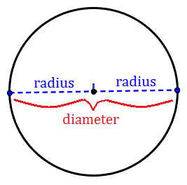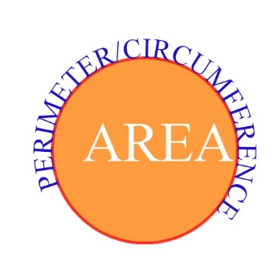

Hint: The Diameter is 2x the radius!

Find the circumference of each circle with the given radius or diameter. Round to the nearest tenth, use 3.14 for

1. 2. 3. A pop can that has a radius of 1.5 in

Find the Area of each circle with the given radius or diameter. Round to the nearest tenth, Use 3.14 for .

4. 5. 6. A CD has a diameter of 4.5 in

Find the radius with the given circumferences and areas. Then find the circumference/area. Round to 2 decimal places.

7. 8. 9.

10. A Ferris wheel has a diameter of 36 ft.

a) How far will an individual travel if the wheel rotates once?

b) How far will they travel during a 2-minute ride if it rotates once every 20 seconds?

**Concept 2A: Arc Length**

Arc Length: The distance from point A to point B, on the outside of a circle

radians = degrees × π / 180°

degrees = radians × 180° / π

Convert the following from degrees to radians, or radians to degrees.

1. 2. Radians 3.

4. 5. Radians 6. $\frac{3π}{2}$ Radians

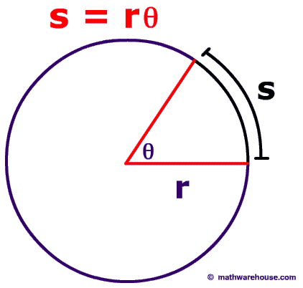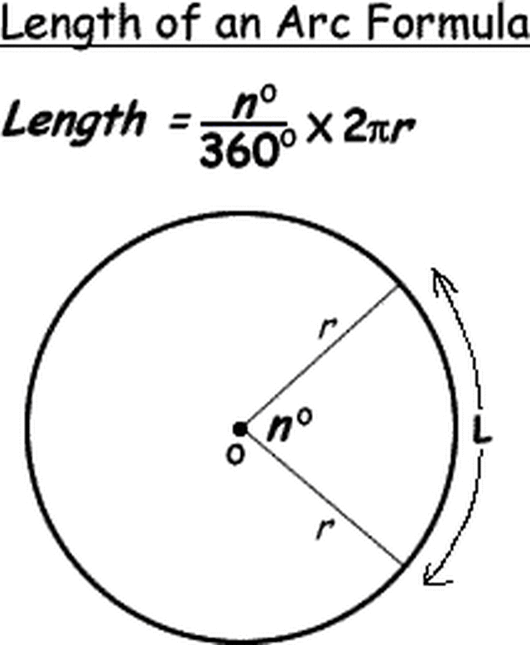

L

L

Example: r=7

n=1.4 Radians

Example: r=7

n=80◦

*****Notice that to find the length of an arc you just multiply the circumference of the circle by the fraction of the circle the length takes up.******

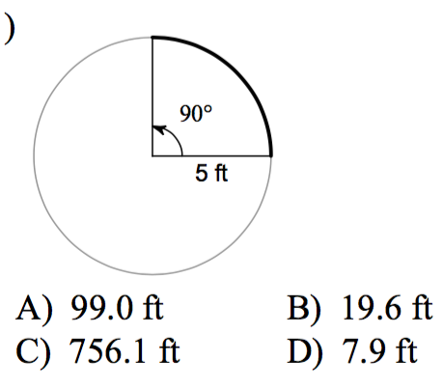Find the arc length to the nearest tenth.

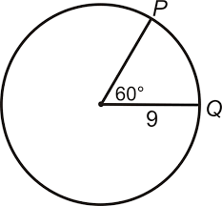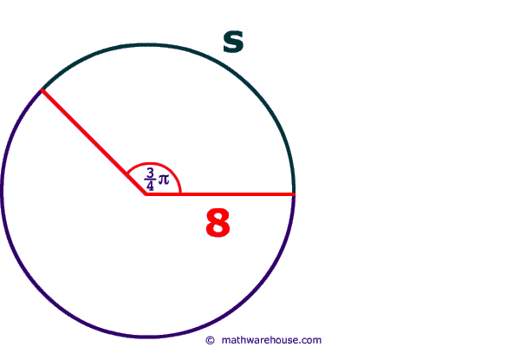7. 8. 9.

10. The minute hand of a clock is 4 inches long. If the hand moves from 1:05 to 1:25, what is the distance the tip of the hand moves, to the nearest tenth?

**Consider a standard 12-hour clock like the one below with a radius of 3 inches.  
Use the shortest path between the two numbers.**

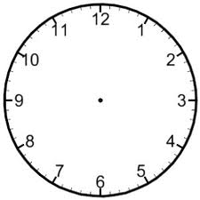11. What is the length of the arc between the 3 and the 8?

12. What is the length of the arc between the 3 and the 4?

13. It is 1:35. What is the length of the arc between the minute and hour hands?

**Concept 2B: Sector Area**

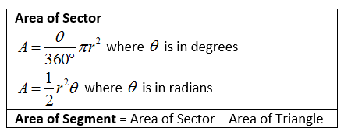Sector Area: The region within a circle bounded by two radii and an intercepted arc

*****Notice that to find the area of a sector you just multiply the area of the circle by the fraction of the circle the sector takes up.******

Find the shaded Sector area in the following circles.

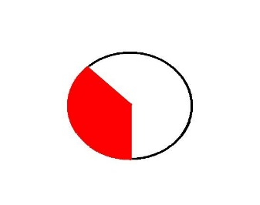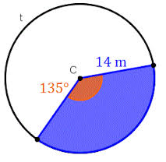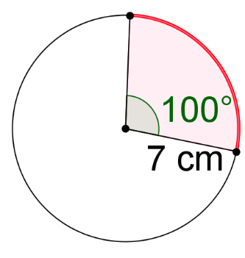1. 2. 3. 3. 4. 5.

r = 2 yds

4. The beam from a lighthouse is visible for a distance of 12 miles. What is the area covered when the beam sweeps in an arc of $150°$? To the nearest tenth.

5. You eat five pieces of a pizza that has a radius of 8 inches. The pizza is divided into eight even slices. What is the area of the pizza you ate?

6. A large pizza has a radius of 9in. What is the area of half of the large pizza?

7. A slice is removed from a pizza with a radius of 7 inches. The length of the crust of the missing slice is 2 in. What is the area of the missing slice?

**Concept 3: Equations of Circles**

Equation of a Circle: ${\left(x-h\right)}^{2}+{\left(y-k\right)}^{2}=r^{2}$

(h,k) is the center of the circle, r is the radius.

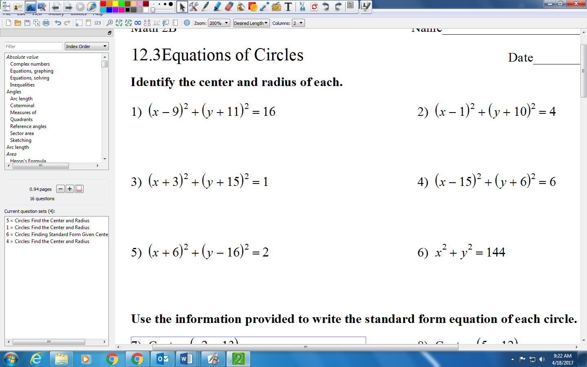Identify the center and radius from equation.

Use center and radius to write equation.

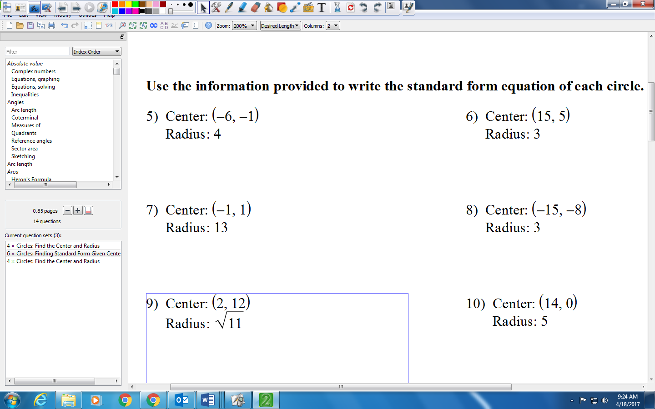

Write the equation of each circle.

9. 10. 11.

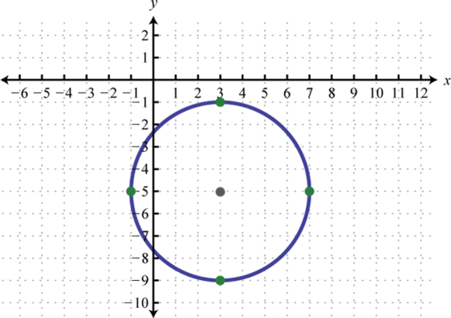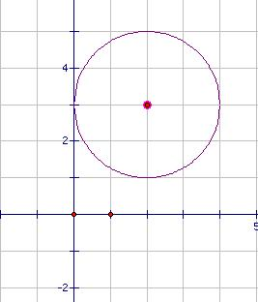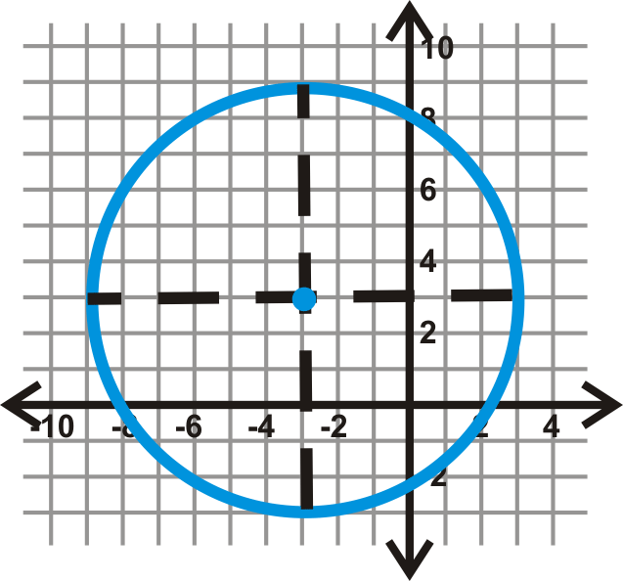

“Completing the Square”

1. Move constant to other side of the equal sign.
2. Put x terms together and y terms together in two sets of parentheses. Leave space.
3. Divide each b term by two and square it. Add the number(s) to both sides.
4. Write left side in factored form.

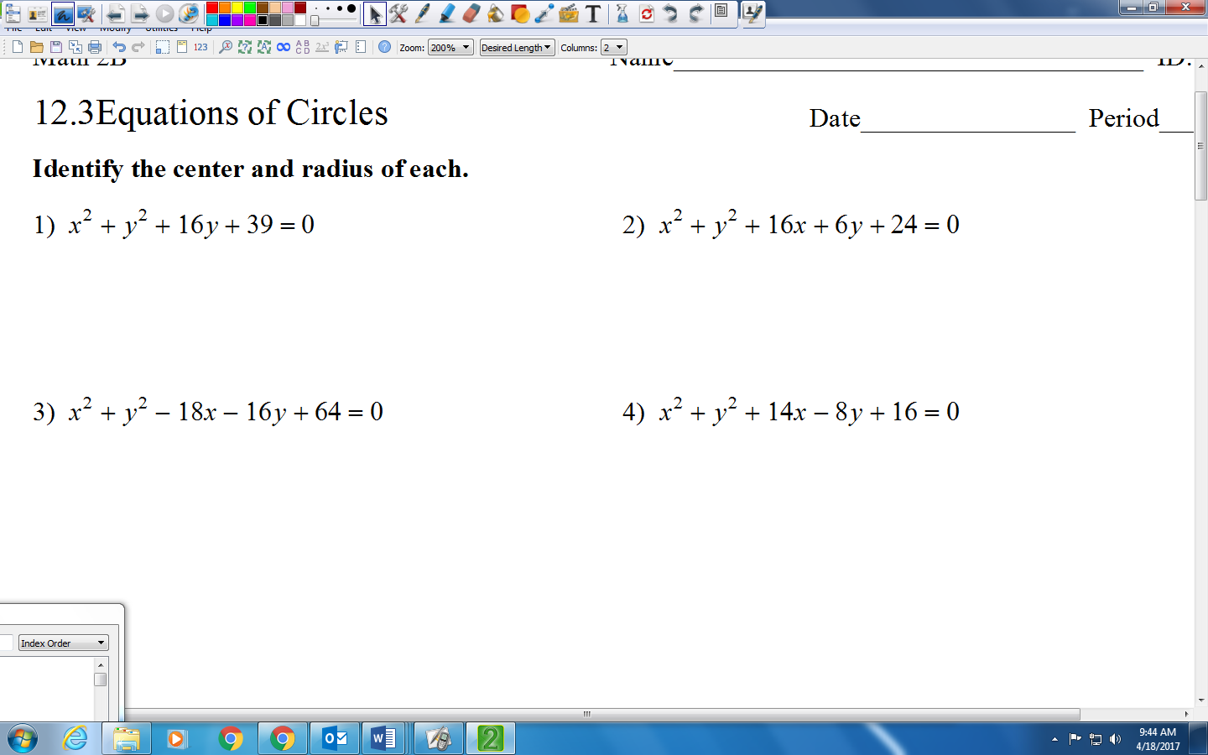Identify the center and radius of the following.

**Concept 4: Circle Angles** Parts of a Circle

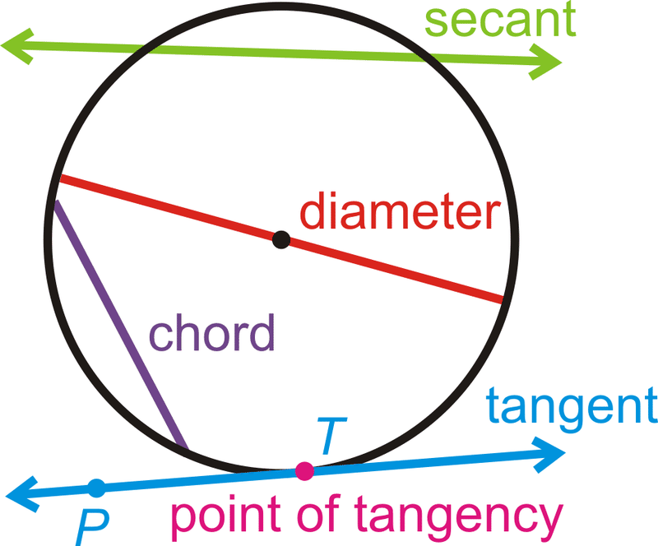Diameter: Line from one side of the circle to the other that goes through the center

Radius: Line from the center to the outside of the circle. Half the diameter.

Secant: Line that goes through a circle intersecting at two points.

Chord: Line from a point on the edge of a circle to another point on the edge of the circle. The diameter is the longest chord.

Tangent: A line that intersects a circle only once on the edge of the circle.

Point of Tangency: Point where a tangent line intersects the circle.

Note that circles are congruent if they have the same radius. Think about when two circles would be similar, knowing that if one shape is a dilation of another, then the two are similar like we learned in our triangles unit.

Label the central angle, inscribed angle, and circumscribed angle of the circle:

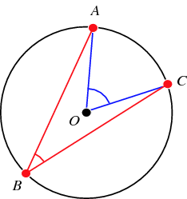

Central angle theorem: The central angle is always twice the measure of the inscribed angle.

Inscribed Angle Theorem: The inscribed angle is always half the angle.

Circumscribed Angle Theorem: The circumscribed angles is equal to 180 degrees minus the measure of the central angle.

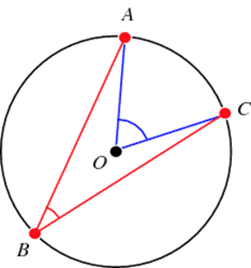

Using your knowledge of the Central angle and inscribed angle theorem, find the value for x.

1. 2.

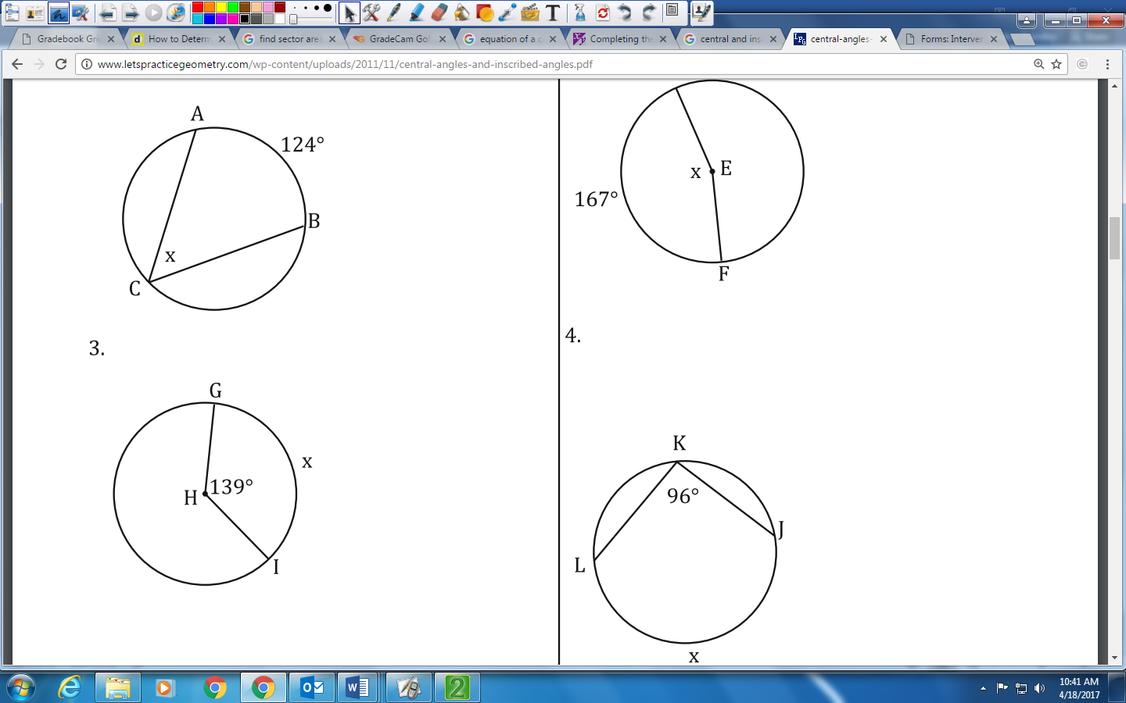

Using your knowledge of the Central angle and inscribed angle theorem, find the value for x.

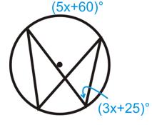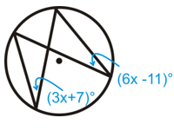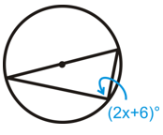

19. 20. 21.

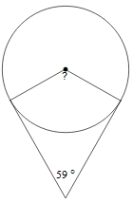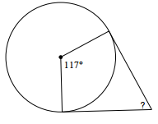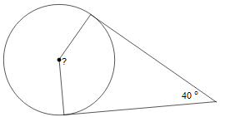Solve for all the unknown angle and the angles formed by the tangent line and radius.

22. 23. 24.

134◦

36◦

49◦

**Concept 5: Inscribed Quadrilaterals**

Quadrilaterals: Four sided figures whose angles add up to 360 degrees.

**Find the measure of each indicated angle.**

|  |  |
| --- | --- |
| 1. | 2. |

**Solve for x.**

|  |  |
| --- | --- |
| 3. | 4. |

|  |  |
| --- | --- |
| 5. | 6. |

Find the measure of **ALL** arcs or angles.

|  |  |
| --- | --- |
| 7. | 8. |
| 9. | 12. $Find m\hat{NS}.$ |
|  |  |