Unit 8
Creating Equations and Systems of Equations

Guided Notes

_________________________________________________
Name

______________
Period

**If found, please return to Mrs. Brandley’s room, M-8.**
Self-Assessment
The following are the concepts you should know by the end of Unit 8. Periodically throughout the unit I will ask you to self-assess on how you are doing on these skills. It is essential for you to be able to identify what you do and do not understand in order to learn effectively. You will use the following scale:
5: Yes! I understand
4: I’m almost there.
3: I am back and forth.
2: I am just starting to understand.
1: I don’t understand at all.

Concept 1: Factoring Preparation
_____ I can write a quadratic in standard form and identify A, B, and C.
_____ I can find and factor out the greatest common factor of a quadratic.
_____ I can identify AC and B and find two numbers that multiply to AC and add to B.
_____ I can factor a quadratic written in 4 terms by grouping.
Concept 2: Factoring
_____ I can factor a quadratic equation when A is 1.
_____ I can factor a quadratic equation when A is not 1.
_____ I can find the solutions of a quadratic once it is in factored form.
Concept 3: Creating Equations
_____ I can write an expression/equation based on a verbal description.
_____ I can write a verbal description based on an expression/equation.
_____ I can write an expression/equation/inequality based on a story problem and then use it to solve the problem.
Concept 4: Systems of Equations
_____ I can solve a system of equations given one linear and one quadratic equation.

Concept 1: Factoring Prep Review
Standard Form of a Quadratic: $Ax^{2}+Bx+C=0$
Put the following quadratics in standard form and list A, B, and C.
1. $3x+5x^{2}=7$ 2. $-4x^{2}=2x-6$ 3. $2x=x^{2}-9$
SF: SF: SF:
A: A: A:
B: B: B:
C: C: C:
Factor out the greatest common factor in the following expressions:
4. $2x^{2}+10x$ 5. $12x^{2}-3x+6$ 6.$5x^{2}-15x+10$ 7.$x^{2}-2x+7$

Given the following quadratics, list what AxC is and what B is, then find two numbers that multiply to AC and add to B.
8. $3x^{2}-7x+4=0$ 9. $x^{2}+8x+16=0$ 10. $2x^{2}+8x+6=0$
AxC: AxC: AxC:
B: B: B:
2 #’s: 2 #’s: 2 #’s:
Factor the following by grouping:
11. $x^{2}+5x-3x-15=0$ 12. $2x^{2}-6x+4x-12=0$ 13. $6x^{2}-8x+3x-4=0$

Concept 2: Factoring Review
Greatest Common Factor
1. $3x-3=0$ 2. $x^{2}-4x=0$ 3. $9x^{2}+6x=0$

Factored: Factored: Factored:
Solved: Solved: Solved:
A=1 Quadratic
4. $x^{2}+5x+6=0$ 2. ${2x}^{2}-8x+8=0$ 3. $x^{2}-5x-14=0$

Factored: Factored: Factored:
Solved: Solved: Solved:
A not equal to 1 Quadratic
7. $6x^{2}-5x-4=0$ 8. $3x^{2}+2x-8=0$ 9. $6x^{2}+7x-3=0$

Factored: Factored: Factored:
Solved: Solved: Solved:
Concept 3: Creating Equations
Sum: the solution to an addition problem
Difference: the solution to a subtraction problem
Product: the solution to a multiplication problem
Quotient: the solution to a division problem

Write the following phrases as a numerical expression:
The sum of five and seven
The difference of twelve and nine
The product of four and six
The quotient of twenty-seven and three

Now try the following:
1. The sum of five times a number n and thirteen?

2. The quotient of four and the quantity of two less than one-third of a number x?

3. The difference of six times a number x and the quotient of the number x and five?

This same idea can applied taking numerical expressions and writing them verbally:
4. $5-\frac{x}{76}$

5. $4+\frac{1}{3}x$

6. $\left(x+2\right)+\frac{7}{x}$

7. A car salesman earns a $30,000 salary plus a commission of $600 for every car he sells. He wants to earn $80,000, how many cars does he need to sell?
EQUATION:

SOLUTION:

8. A school football game charges $5 for students and $8 for adults. The football team really wants new uniforms that will cost $1200. If 50 adults come. How many children need to be with them?
EQUATION:

SOLUTION:

9. Three more than 6 times the square of a number is 57. Find the number.
EQUATION:

SOLUTION:

10. Bobby is having a growth spurt. He is currently 34 inches tall. If he grows 2 inches a month (I told you, growth spurt) how many months will it take for him to reach 4 feet tall?
EQUATION:

SOLUTION:

11. Savannah makes a square garden but realizes that it’s too small to grow everything she wants to grow. She only has room to extend it two feet on one side and three feet on the other. The area of the new garden is 156 square feet. How long was one side of the original square garden?
EQUATION:

SOLUTION:

Concept 4: Systems of Equations
When we have a single equation, it is impossible to solve if it has more than one variable. However, if we have two equations and two variables we can solve it using substitution or elimination. We are going to solve them using substitution.
Linear Equations:
- $y=x+5$ 2. $y=5x+2$
$y=2x-3$ $y=3x-8$

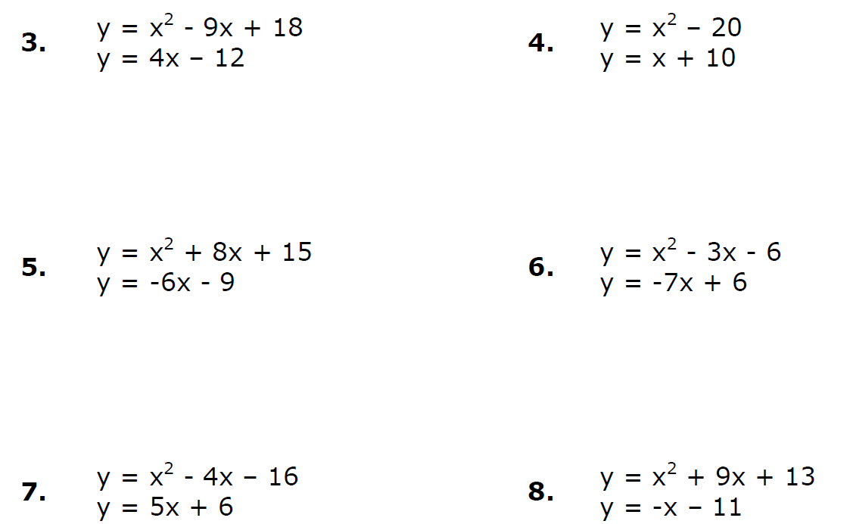
A Linear and Quadratic Equation:

